**TS SDP4 (Cloud DevOps)**

**ID NO:** 190030677  **Name:** K. Sravani

**Skilling-1**

1. Create an AWS account and set alarm for bill alerts which may cross $1 in cost for the services

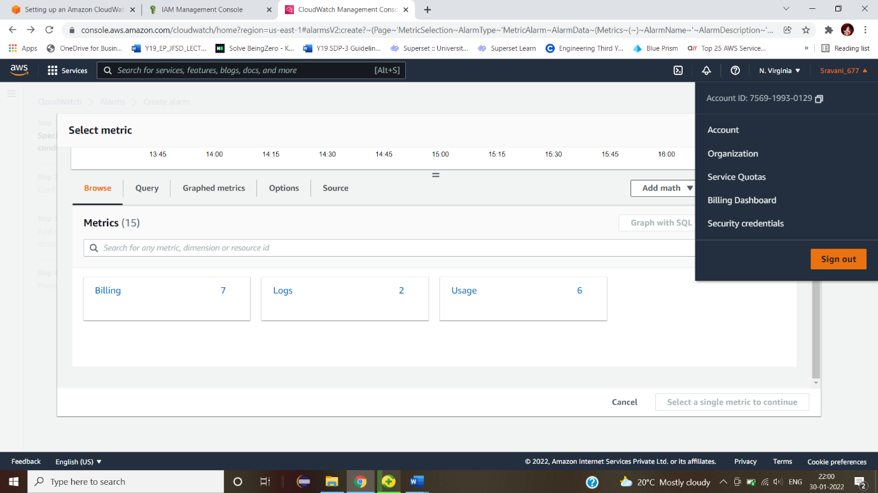

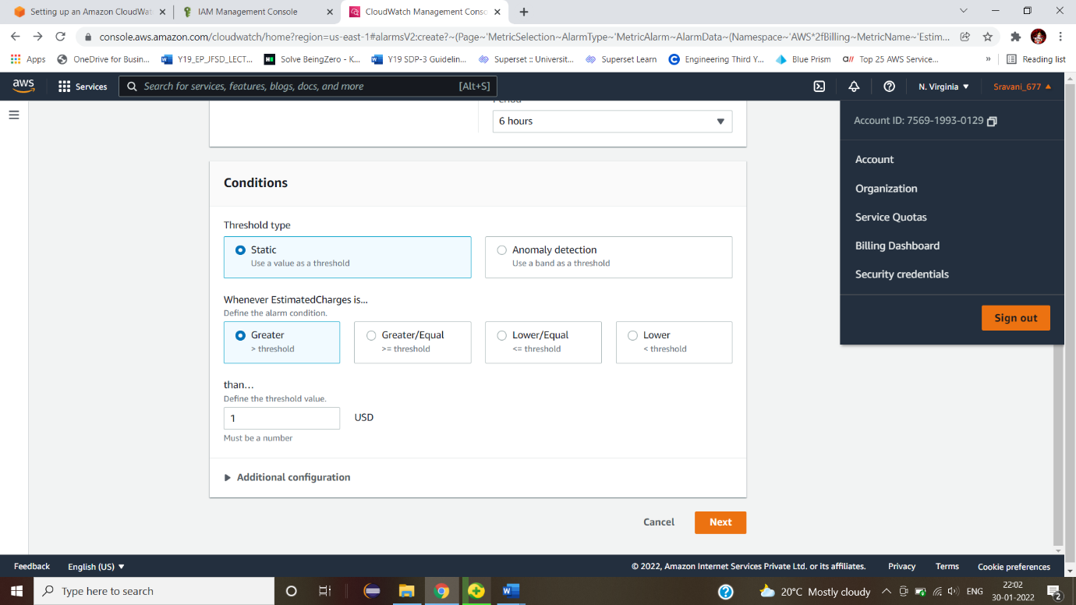

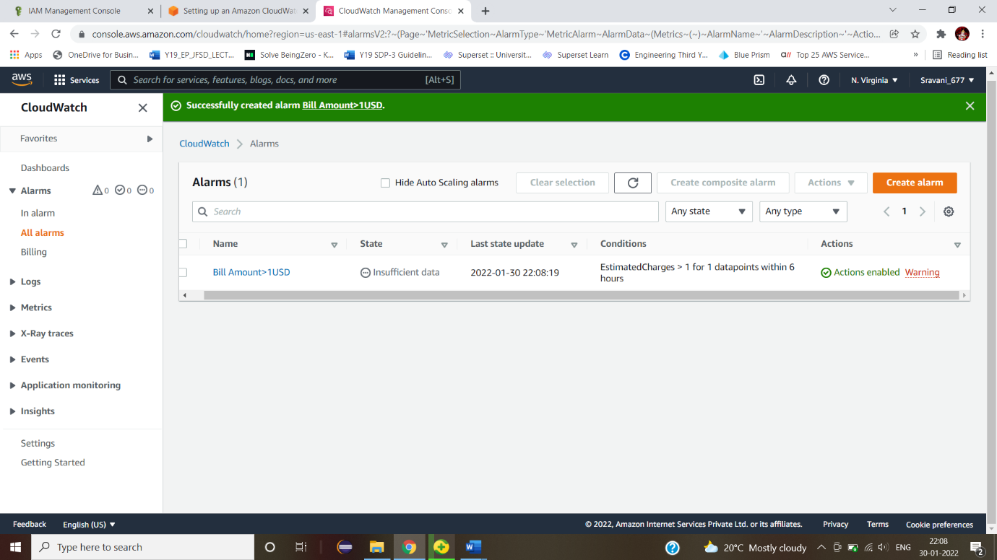

2. The ready made application with its pre defined scripts are ready with you now. The scripts will cover the data fetching from s3 bucket, unzipping the data fetched (source code), installing the environment and required packages and finally, hosting port number. AWS is also providing you with default VPC and subnet. In this case, you need to use the availability to host the web page in EC2 instances (linux based). Create necessary roles in your account for providing access to other AA screenshot of a computer
WS services like S3.

